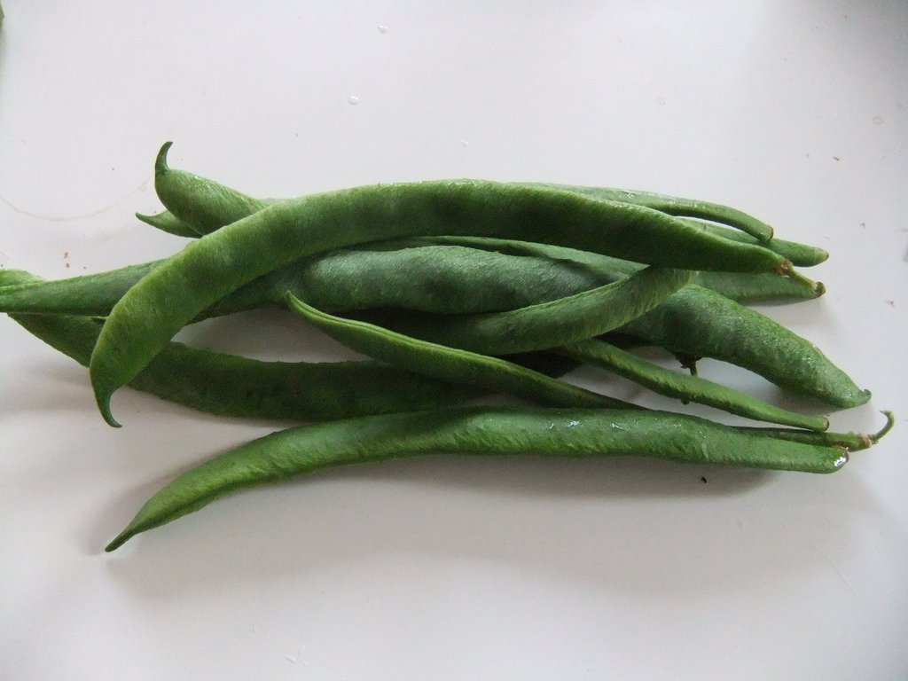**Today is…**

**Today is Monday x 2**  
**Monday -- runner beans**   
**All you hungry children, come and eat it up!**

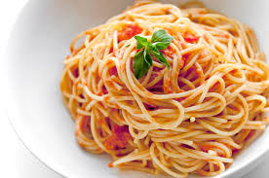**Today is Tuesday x 2**   
**Tuesday -- chicken**  
**All you hungry children, come and eat it up!**

**Today is Wednesday x 2**  
**Wednesday -- spaghetti**  
**All you hungry children, come and eat it up!**

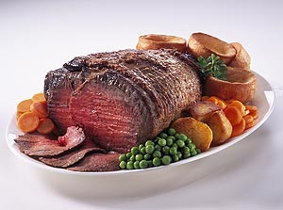**Today is Thursday x 2**  
**Thursday -- roast beef**  
**All you hungry children, come and eat it up!**

**Today is Friday x 2**   
**Friday -- fresh fish**  
**All you hungry children, come and eat it up!**

**Hello song**

H.E.L.L.O x 2

This is how we say hello x 2

Move your feet to the beat x 2

Can you feel my heart beat? x 2

Rhythm created by clapping, clicking, body clapping etc

**Good morning song**

Good morning, good morning, good morning

It’s now another day

The sun is up and shining

It’s time to learn and play (clap, clap)

Good morning, good morning, good morning

We have lots of things to do

Your sleeping time has ended

The day starts all brand new

**When I was….**

When I was ONE I sucked my thumb, the day I went to sea.

I jumped aboard a pirate ship, and the captain said to me -

We're going this way, that way, forwards and backwards,

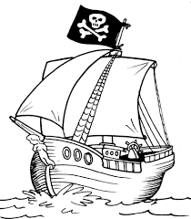Over the deep blue Sea,

We're going this way, that way, forwards and backwards,

That's the life for me!

When I was TWO I buckled my shoe, the day I went to sea.

I jumped aboard a pirate ship, and the captain said to me -

When I was THREE I bashed my knee, the day I went to sea.

I jumped aboard a pirate ship, and the captain said to me -

When I was FOUR I knocked on the door, the day I went to sea.

I jumped aboard a pirate ship, and the captain said to me -

When I was FIVE I learnt to dive, the day I went to sea.

I jumped aboard a pirate ship, and the captain said to me -

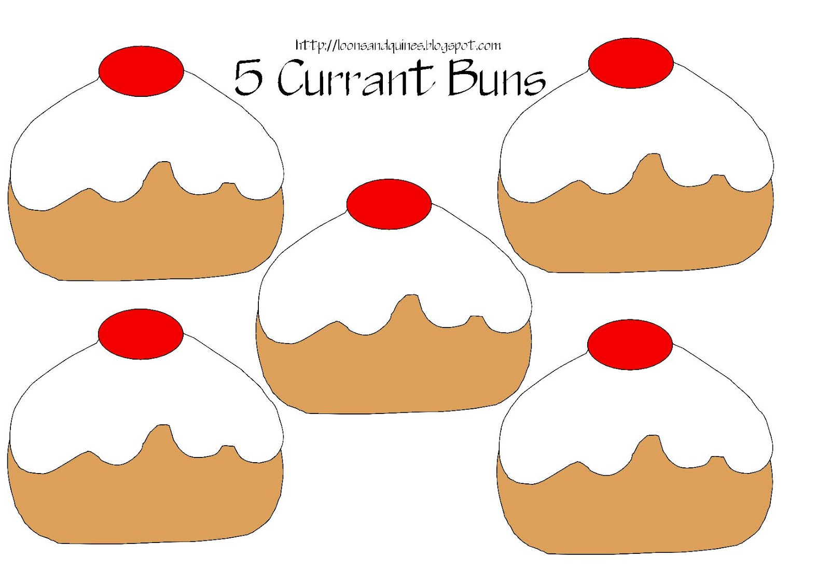**Five currant buns**

FIVE currant buns in a baker's shop, Round and fat with a cherry on top.

Along came a boy with a penny one day, Bought a currant bun and took it away.

FOUR currant buns in a baker's shop, Round and fat with a cherry on top.

Along came a girl with a penny one day, Bought a currant bun and took it away.

THREE currant buns in a baker's shop, Round & fat with a cherry on top.

Along came a boy with a penny one day, Bought a currant bun and took it away.

TWO currant buns in a baker's shop, Round and fat with a cherry on top.

Along came a girl with a penny one day, Bought a currant bun and took it away.

ONE currant bun in a baker's shop, Round and fat with a cherry on top.

Along came a boy with a penny one day, Bought a currant bun and took it away.

Bought a currant bun and took it away!

**One, two, three, four, five,….once I caught a fish alive**

One, two, three, four, five,

Once I caught a fish alive.

Six, seven, eight, nine, ten,

Then I let it go again.

Why did you let it go?

Because it bit my finger so.

Which finger did it bite?

This little finger on the right.

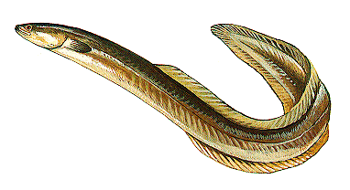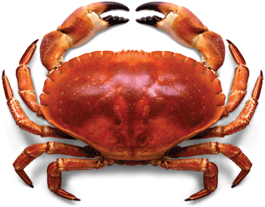

**Wind the bobbin up**

Wind the bobbin up, wind the bobbin up

Pull, pull, clap, clap, clap

Wind the bobbin up, wind the bobbin up

Pull, pull, clap, clap, clap

Point to the ceiling, point to the floor

Point to the window, point to the door

Clap your hands together now

One, two, three

Slap your hands upon your knee

Wind the bobbin up, wind the bobbin up

Pull, pull, clap, clap, clap

Wind the bobbin up, wind the bobbin up

Pull, pull, clap, clap, clap

Point to the ceiling, point to the floor

Point to the window, point to the door

Clap your hands together now

One, two, three

Slap your hands upon your knee

**It’s raining outside but I don’t mind**

It’s raining outside but I don’t mind I’ve got everything that I need!

It’s raining outside but I don’t mind I’ve got everything that I need!

I’ve got a Hat, Umbrella, Wellington Boots and a Scarf

I’ve got a Hat, Umbrella, Wellington Boots and a Scarf

Repeat, missing out one more word each time and only doing the action instead.

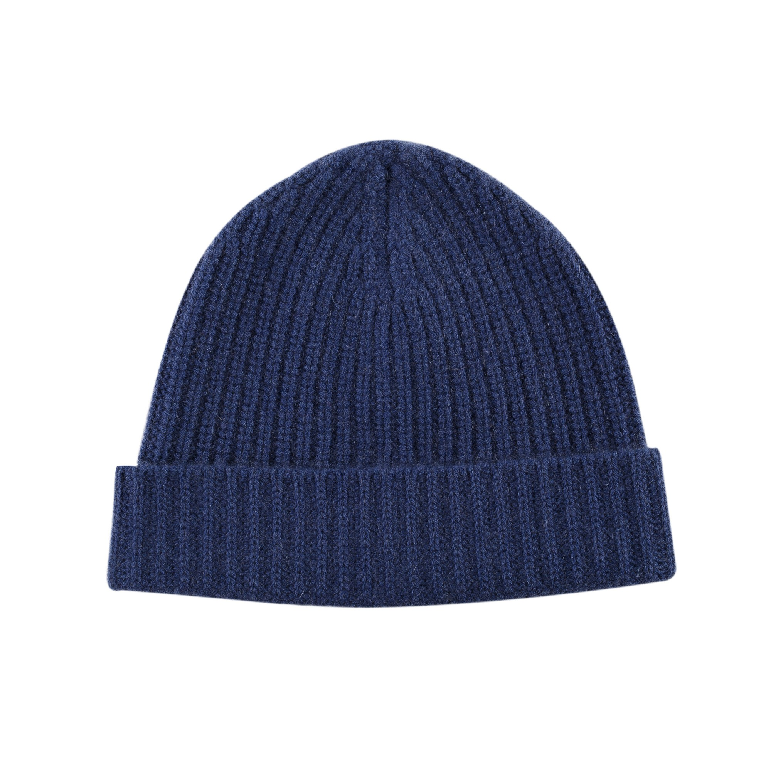

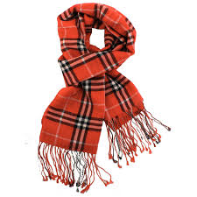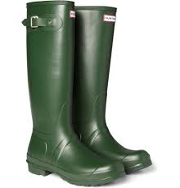

**1 – 10 fingers song**

1 little, 2 little, 3 little fingers;

4 little, 5 little,  6 little fingers;

7 little, 8 little, 9 little fingers;

10 fingers on my hand

**Whole world in his hands**

He’s got the whole world in his hands

He’s got the whole wide world in his hands

He’s got the whole world in his hands x 2

Sun and the moon in his hands

My brothers and my sisters in his hands

Birds and the Trees in his hands

Wind and the rain in his hands

Everybody here in his hands

**The wise man built his house upon the rock**

The wise man built his house upon the rock.

The wise man built his house upon the rock.

The wise man built his house upon the rock.

And the rain came tumbling down.

The rain came down and the floods came up.

The rain came down and the floods came up.

The rain came down and the floods came up.

And the house on the rock stood firm.

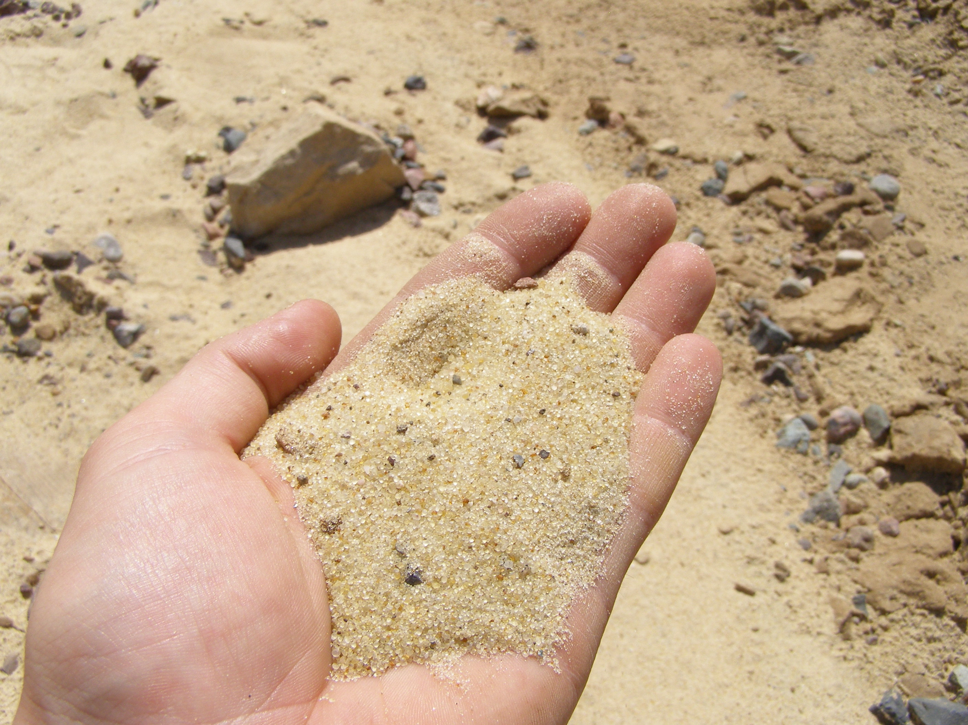The foolish man built his house upon the sand

The foolish man built his house upon the sand

The foolish man built his house upon the sand

And the rain came tumbling down.

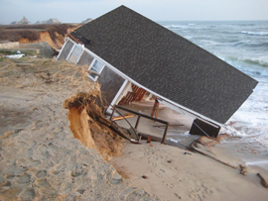The rains came down, and the floods came up,

The rains came down, and the floods came up,

The rains came down, and the floods came up,

And the house on the sand washed away.

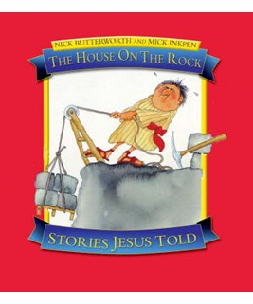

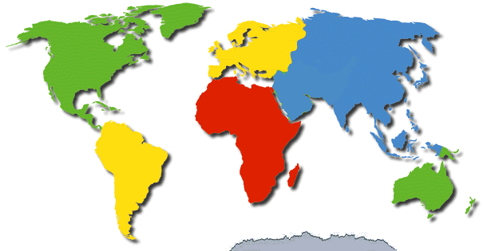**The Continents Song**

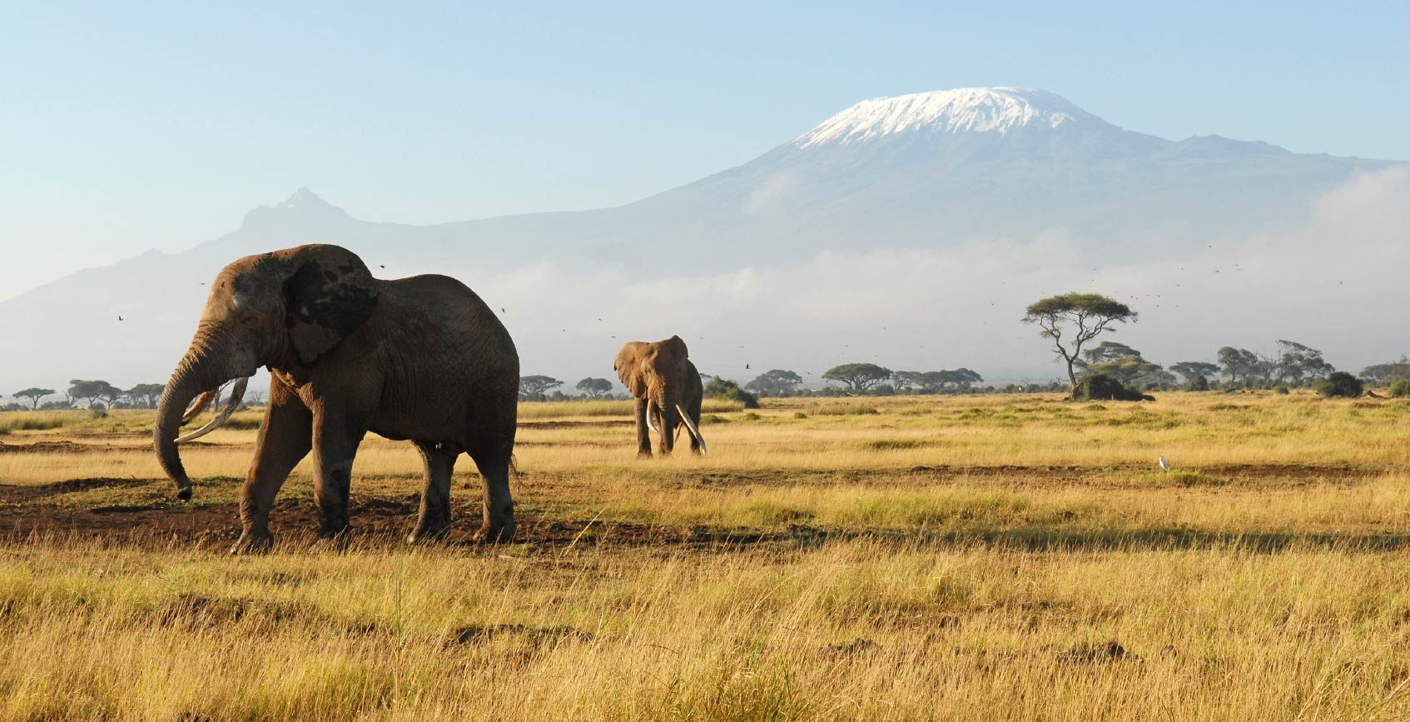To learn the seven continents,

think of the letter A.

And when you’re down to only one,

an E will save the day.



There’s Africa, Antarctica,

Australia, Asia too.

The oceans run between them

with their waters deep and blue.

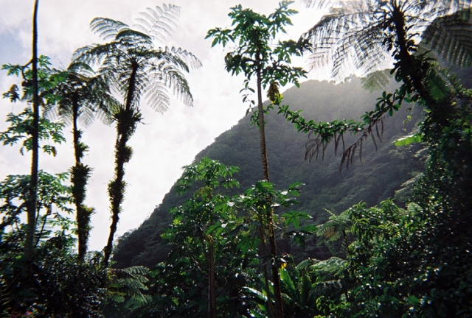

There are also two Americas,

North and South you see.



And now we’re coming to the end,

Europe starts with E!