Breaking down the virtues

The language of virtue is rich and complex. Each virtue has many layers of meaning. Take forgiveness as an example; within this virtue a teacher might choose to focus on any one, or a combination of the following themes:

* Forgiveness as letting go of anger and the benefits to the forgiver.
* Saying sorry and asking for forgiveness when you have hurt somebody.
* We all make mistakes.
* Second chances. When are they appropriate?
* The idea that extending love and kindness to someone who has treated you unfairly is a sign of strength.
* The difference between forgiveness and vengefulness.
* The difference between forgiveness and reconciliation.

All interesting and viable options, the teacher’s decision about what to focus on will shape the children’s understanding of what the word forgiveness means and how it applies to their own lives.

**Our Virtue Literacy lesson plans**

In our Virtue Literacy lesson plans, eachvirtue is broken down into a ‘character focus’ specific to each year group. These are thoughtfully sequenced throughout the infant phase. Through this planning, teachers are supported to deliver a coherent Programme that avoids repetition and builds pupils’ understanding year on year as shown in the example below:

|  |  |
| --- | --- |
| Reception | I feel better when I forgive. |
| Year 1 | It can feel very unfair to forgive someone, but it’s better for you in the long run. |
| Year 2 | When someone hurts me, I show love and kindness by forgiving them. |

A description of each virtue is also provided in the lesson plans to highlight these nuances for the teacher. It is the richness of the virtues which enables pupils to revisit them each academic year, gaining an increasingly sophisticated understanding as they progress through the Programme.

**Book choice**

The books selected as a stimulus for each unit have been carefully matched to the virtue focus for each year group. The ‘drawing out the virtue’ section of the lesson plans guides teachers to draw out the moral dilemmas in the story through questioning to push pupils’ understanding of the virtue beyond basic, everyday comprehension of the word.

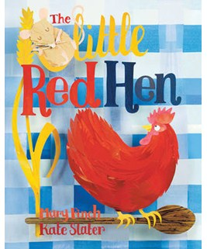

For example, when pupils first study fairness through the Virtue Literacy Programme, children read the story of *the Little Red Hen*, who couldn’t convince any animal to help

her make bread, even though they were all happy to help her eat it in the end! This helps children distinguish situations in which everyone automatically gets the same, from those in which entitlement has been worked for or properly earned.

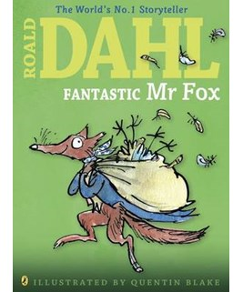

Then in Year 1 the children read Roald Dahl’s *Fantastic Mr Fox* and children discuss whether it is fair for Mr Fox to steal food to feed his hungry family, and whether it is acceptable to steal from the wicked Boggis, Bunce and Bean after they destroyed Mr Fox’s home. Through this story children consider ideas about justice and fairness learning that we have to look at things from different sides in order to know what is fair.

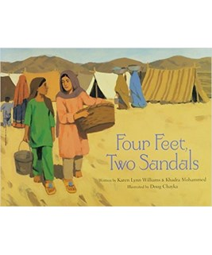

In Year 2 children hear the story *Four Feet, Two Sandals,* which is about 2 refugee girls in Pakistan, who each find one sandal of a pair. They are both willing to sacrifice their one sandal so the other can wear a pair. This provides a rich foundation for a guided discussion about fairness and it’s implications for how we treat others.

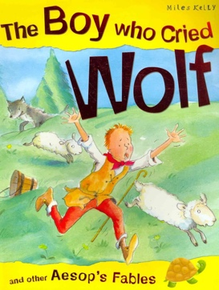

Another example is honesty. In Reception the Aesop’s fable *The Honest Woodcutter* teaches children that even when no-one is looking, honesty is always the best policy.

Then in Year 1 children hear the story of *George Washington and the Cherry Tree*, which models for them that when they’ve done something wrong, owning up is always better than covering-up.

Then in Year 2, children read the cautionary tale of The Boy Who Cried Wolf, which explores more complex issues of trust, the consequences of dishonesty and a person’s standing and reputation in society.